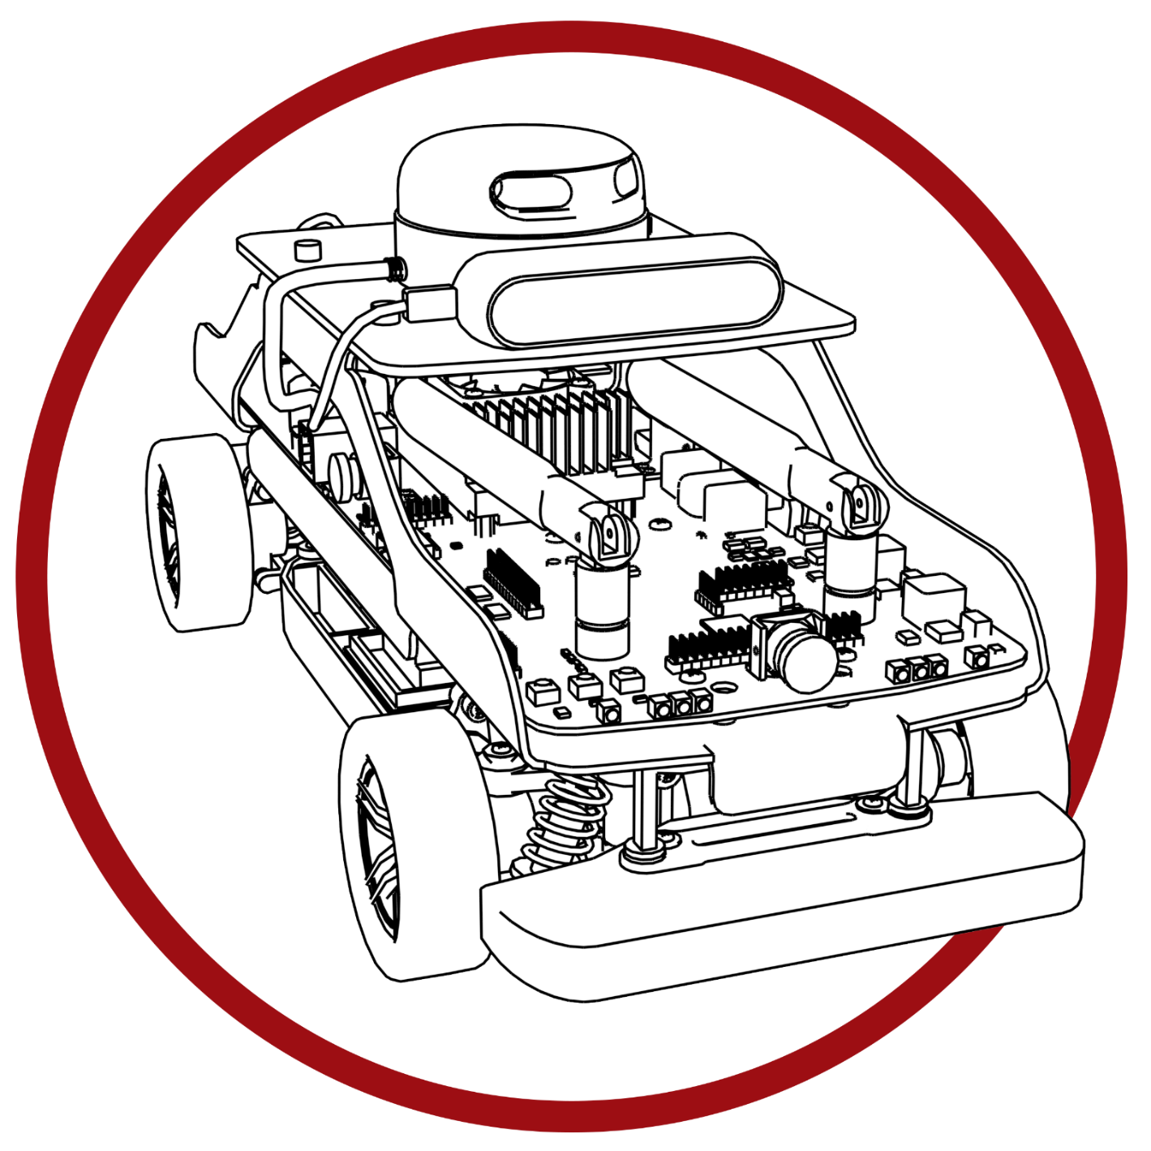

**SELF-DRIVING CAR STUDIO**

© 2023 Quanser Inc., All rights reserved.

Quanser Inc.

119 Spy Court

Markham, Ontario

L3R 5H6

Canada

info@quanser.com

Phone: 19059403575

Fax: 19059403576

Printed in Markham, Ontario.

For more information on the solutions Quanser Inc. offers, please visit the web site at:  
<http://www.quanser.com>

This document and the software described in it are provided subject to a license agreement. Neither the software nor this document may be used or copied except as specified under the terms of that license agreement. Quanser Inc. grants the following rights: a) The right to reproduce the work, to incorporate the work into one or more collections, and to reproduce the work as incorporated in the collections, b) to create and reproduce adaptations provided reasonable steps are taken to clearly identify the changes that were made to the original work, c) to distribute and publicly perform the work including as incorporated in collections, and d) to distribute and publicly perform adaptations. The above rights may be exercised in all media and formats whether now known or hereafter devised. These rights are granted subject to and limited by the following restrictions: a) You may not exercise any of the rights granted to You in above in any manner that is primarily intended for or directed toward commercial advantage or private monetary compensation, and b) You must keep intact all copyright notices for the Work and provide the name Quanser Inc. for attribution. These restrictions may not be waved without express prior written permission of Quanser Inc.

Self-Driving Car Studio

Student Guide

Self-Driving Car Studio

Quanser’s Self-Driving Car Studio contains curriculum designed to get students familiar with topics related to autonomous vehicles. Topics are intuitively subcategorized for convenience. Coding lab guides are developed in python and can be used with both a physical and virtual implementation of the QCar.

A. Getting Started

Teaching documents are meant to guide students on a series of skills activities designed to cover topics related to self-driving vehicles.

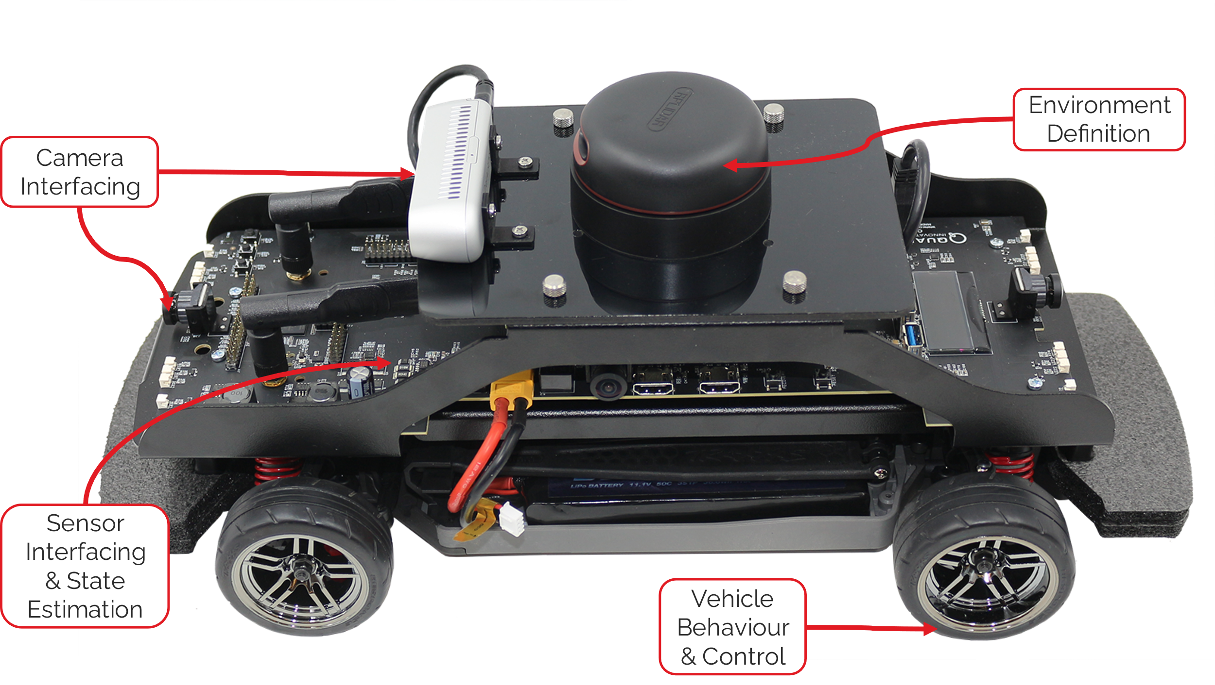

High level topics covered by the skills activities

B. Activity Structure

Skills activities contain two documents for students to read as they get familiar with self-driving car concepts.

* Concept Review
* Lab Guide

It’s encouraged for students to use the **Concept Reviews** to become familiar with the theoretical concepts being presented during each skill activity. **Lab Guides** describe the workflow students follow during each stage of the self-driving vehicle pipeline. The coding language students should be familiar with is Python.

C. Workspace Deployment

Students have the flexibility to use the teaching content with a physical and virtual representation of the QCar.

|  |  |
| --- | --- |
|  |  |
| Physical QCar | Virtual QCar |

Skills activities are also designed to work with the physical and virtual environments, Within Quanser Interactive labs confirm you have selected the correct workspace for running the virtual map:

Skills activities will be ran using the **QCar Plane**, however there is several other workspaces that are available as well such as the **QCar Cityscape, QCar Cityscape Lite, and the QCar Studio**.

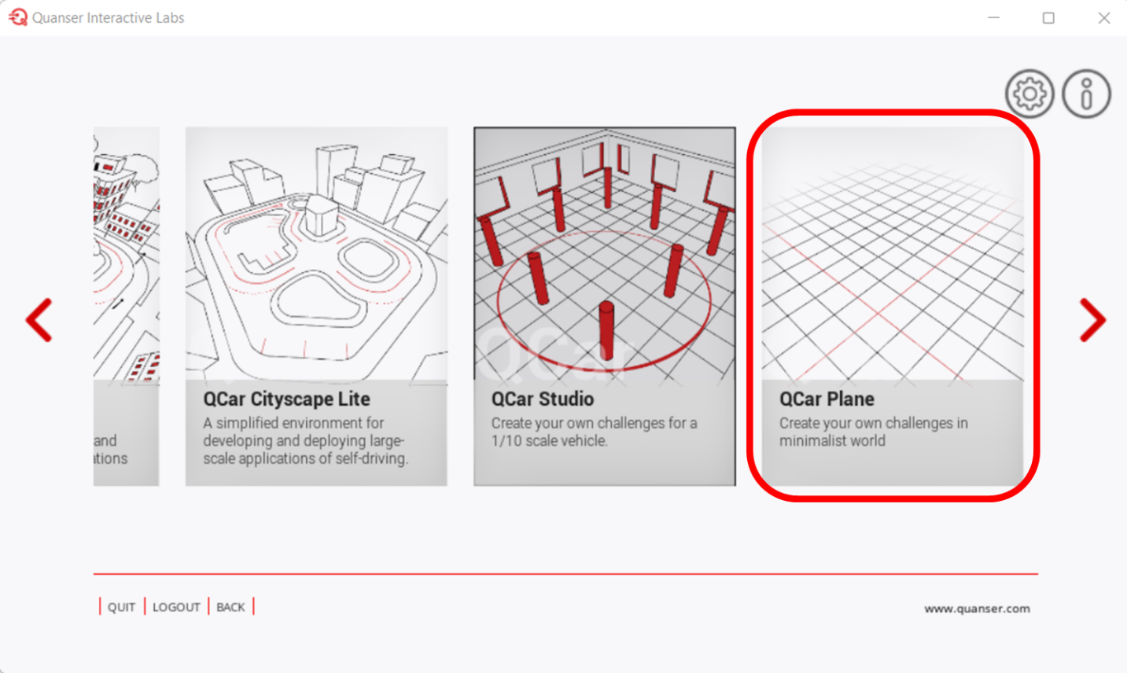

D. File Structure

The skills activities will import different libraries depending on use for the virtual or physical QCar. If you are using the virtual QCar your folder structure should be:

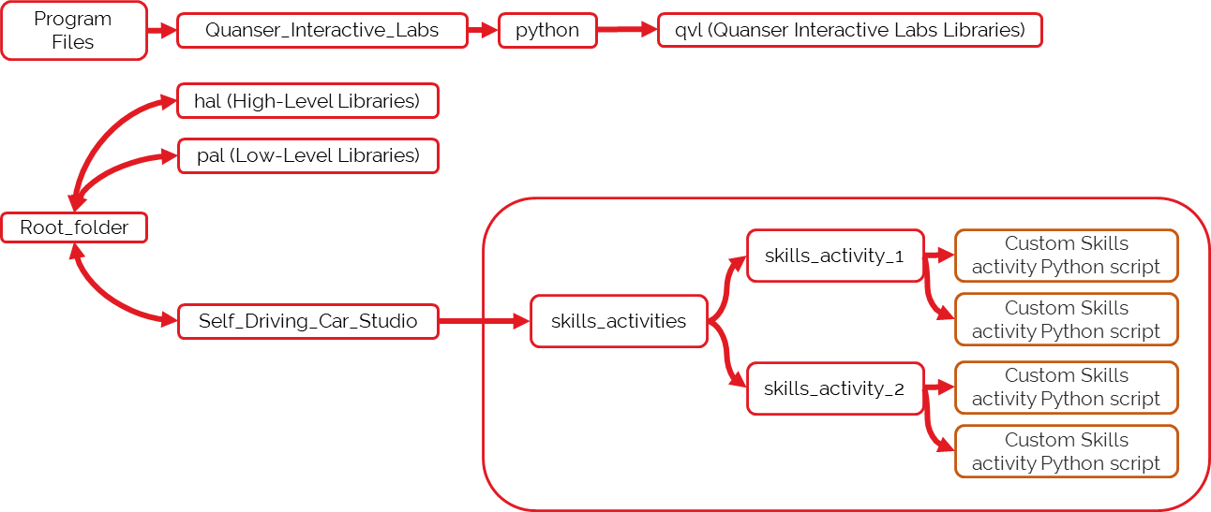

Code structure for the Virtual QCar

For code being ran directly on the QCar the Quanser_Interactive_Labs subdirectory **will not** be included.

|  |
| --- |
|  |
| Code structure for the Physical QCar |

E. Running Skills Activities

Accessing IO on the physical QCar requires the current user to have **sudo** authority. Example:

|  |
| --- |
| sudo PYTHONPATH=$PYTHONPATH python3 <PYTHON FILE NAME>.py |

For skills activities being ran using Quanser Interactive Labs:

|  |
| --- |
| python3 <PYTHON FILE NAME>.py |

F. Lab Guide Requirements

Prior to running the lab guides make sure the following python packages are installed on your system:

|  |  |
| --- | --- |
| * opencv-python==4.4.0.46 * Python => 3.8.0 * pyqtgraph == 0.12.4 * PyQt6 == 6.3.1 | * Matplotlib == 3.5.1 * pytransform3d == 22.2.2 * scipy == 1.7.3 |

In your command line you can use pip to accomplish this quickly by copying and pasting the following:

*Windows Users:*

|  |
| --- |
| pip install opencv-python==4.4.0.46 pyqtgraph==0.12.4 PyQt6==6.3.1 matplotlib==3.5.1 pytransform3d==22.2.2 scipy==1.7.3 |

*Linux Users:*

|  |
| --- |
| sudo pip3 install opencv-python==4.4.0.46 pyqtgraph==0.12.4 PyQt6==6.3.1 matplotlib==3.5.1 pytransform3d==22.2.2 scipy==1.7.3 |

© Quanser Inc. All rights reserved.

Solutions for teaching and research. Made in Canada.